Brief Use Cases:**\***REVISED*

# **Table of Contents**

**Use Case Diagram 2**

**Brief Use Cases 2-3**

# 

City Builder Use Case Diagram

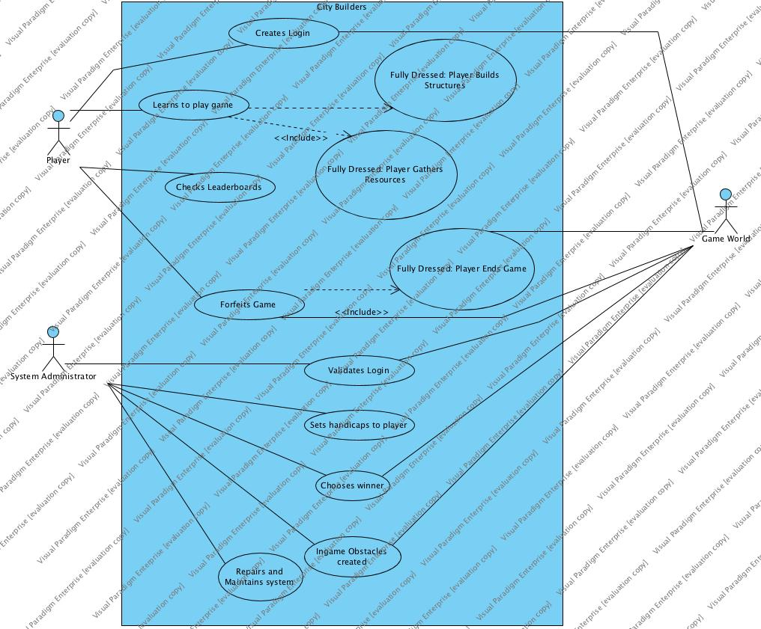

City Builder Brief Use Cases

1. Player creates login
   1. Player wants to be able to use software. The player must create and ID name and password to allow the use of software whenever.
2. Administrator validates player login
   1. Administrator checks if username is allowed and that no other user has taken the same username upon login creation.
3. Player learns to play game
   1. The player wants to start the game and upon starting the game can see on the board what they must do to win. Admin notifies the player what they must do to win, and the player learns on the way as the game goes on.
4. Administrator sets handicaps to players
   1. Administrator sees a player has a noticeable lead over other players. Administrator can set some handicaps to the player to give the other players a chance to catch up.
5. Administrator chooses winner
   1. Administrator chooses winner if the game is held for too long or majority of the players wish to end the game sooner. Administrator must close the system after the game concludes.
6. Player checks leaderboards
   1. A player wishes to see how their statistics compare to other players. The player will select the leaderboards option in the menu. The player can see their ranking amongst other players. After they are finished, the player may select the option to return to the menu.
7. Player forfeits game
   1. A player would no longer like to play the game. The player will select the option to leave the game. All structures that they built and resources that they acquired will go back to the supply.
8. Administrator creates obstacles
   1. One player has achieved a sizeable advantage over the others. The system administrator was notified and chooses an appropriate response so that the players are back to a level playing field.
9. Administrator maintains the system
   1. The administrator must turn on the system in order for the players to be able to play. The administrator must also close the system after the game concludes.

|  |  |  |
| --- | --- | --- |
| Date | Phase | Info |
| 10/01/18 | Inception | Fully dressed usecases, usecases, vision, etc. |
| 10/29/18 | Elaboration | Updated fully dressed usecases, usecases, vision statement, glossary, etc. With rubric updates. Created Implementation model, Design Model, SAD, and Domain Model |
| 12/08/18 | Elaboration | Update once again to our Fully Dressed cases. More detailed use cases based on our scenarios for the the fully dressed. |